Assignment 6

Gaurav Sangappa – PES1201700282

Ananya Nair – PES1201700146

Abhilash Balaji – PES1201700041

Pranav Kelkar – PES1201700174

Problem statement:

On a chosen time-series dataset, analyse the autoregressive moving average (ARMA) and from it, the autoregressive integrated moving average (ARIMA) and their respective Mean Squared Errors (MSE).

ARMA

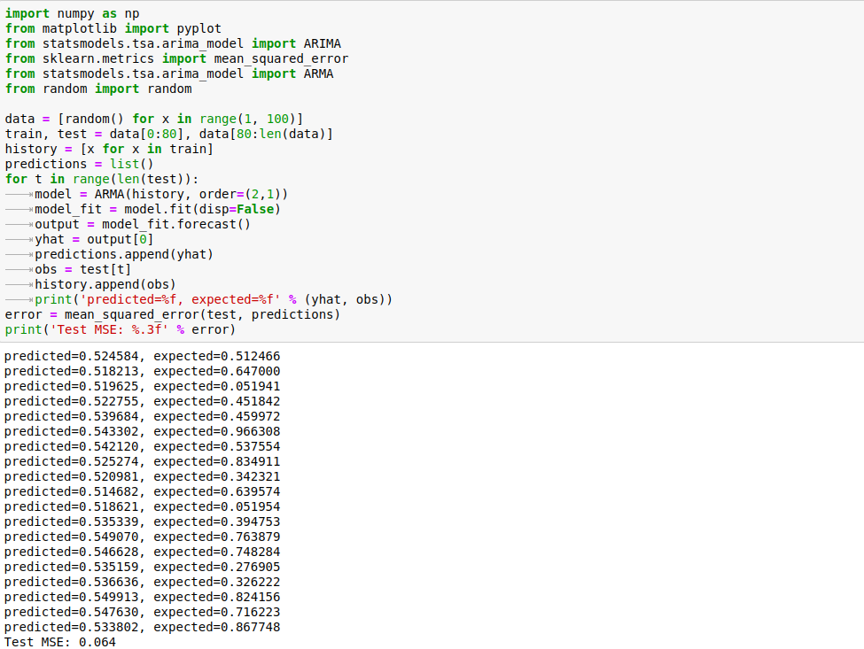

ARIMA

